**Step1:Create project folder Structure.**

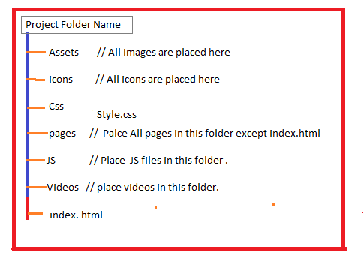

1.1 .Naming convension for Block, element, modifier.

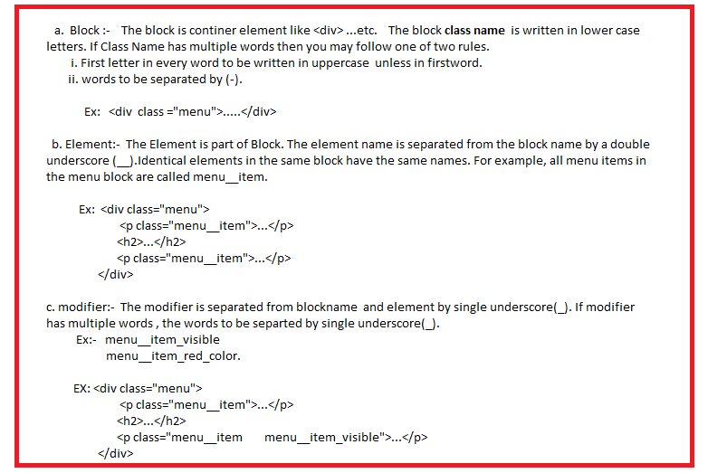

1.2. Naming conventions to images and icons filenames.

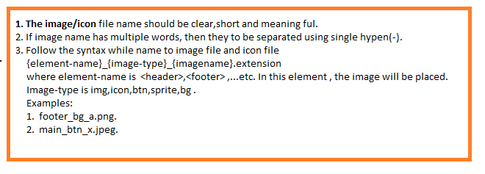

1.3. Naming conventions to css file names.

The filename should be short,clear and meaning ful.

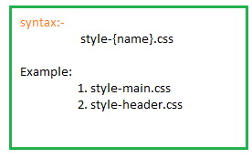

1.4 Naming conventions to JS filenames.

The filename should be short,clear and meaning ful.

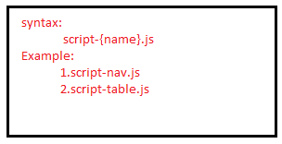

**Step2:.The following web-sites are useful while developing websites.**

**2.1**. [www.unsplash.com](http://www.unsplash.com)

This web site provides quality images category wise.

**2.2.** **The font- awesome is font and icons tool kit.** It provides over 675 icons which are available in SVG, PNG, as well as in web font format for better usability and scalability. The advantage of using font icons is, you can create icons of any color just through applying the CSS [color](https://www.tutorialrepublic.com/css-reference/css-color-property.php) property. Also, to change the size of icons you can simply use the CSS [font-size](https://www.tutorialrepublic.com/css-reference/css-font-size-property.php) property.

Thetool kit url : <https://stackpath.bootstrapcdn.com/font-awesome/4.7.0/css/font-awesome>. min. css

Step:-1 Put the following line <head> section.

<linkrel="stylesheet"href="https://stackpath.bootstrapcdn.com/font-awesome/4.7.0/css/font-awesome.min.css">

Step:2 use following syntax.

<I class=”fa fa-classname/iconname”></i>

**2.3.** If u are developing the website using bootstrap then bootstrap provides around 1300 glyph-icons in SVG and webfont formats.

Url: <https://cdn.jsdelivr.net/npm/bootstrap-icons@1.5.0/font/bootstrap-icons.css>

Step1: write the following statement in <head> section.

<linkrel="stylesheet"href="https://cdn.jsdelivr.net/npm/bootstrap-icons@1.5.0/font/bootstrap-icons.css">

Step:2 use following syntax.

<I class=””></i>

2.4. The following website is used ful for colors.

<https://.coolors.co>

2.5 . For various fonts, use following website.

<https://fonts.google.com>

**Step3:. Collect the following resource according to mock-ups.**

3.1. Collect Images and place them in Asset folder.

3.2. Collect following icon types and place them in icon folder.

a. shortcut icon of project.

b. Form related icons

c. Favicon.

d. Navigtion bar related icons.

e. Button related icons.

3.3. Select color names/codes.

Ex: Primary color, secondary color…etc.

**Step:4. Select one of font-families for various elements of web page using following table.**

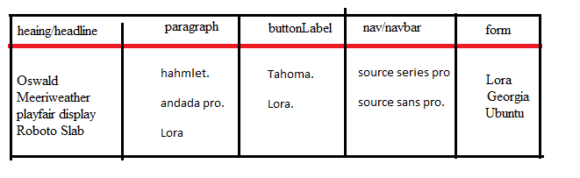

**Step:5. Follow the font-size for various elements on various media contents using following table.**

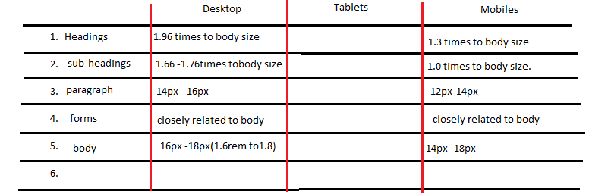

**Step:6**. **Collect the ‘mock-up’ from the UX designer.**

**Step:7. Write a code of Global styles in ‘style.css’ file.**

1. Set margin, padding as 0px to all elements.(i.e) Universal style sheet *{ … }

2. Create ‘global CSS variables’ in style.css file.

Scenario: we declare the variables for storing color names/values,font-size,font-family name of elements.

Ex:- --heading-color: brown;

--heading-font-size: 34px;

3. using element names as selector, Create ‘global style sheets’ in style.css file.

4. using class names as selector , create ‘global style sheets’ in style.css file.

Consider the scenario:

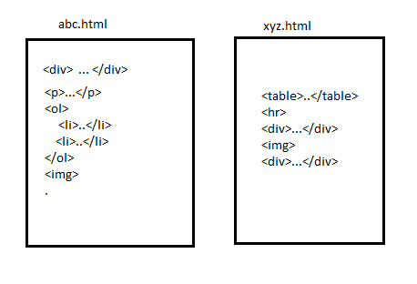

Q) When do we create global styles sheets using element name as selector?

A) If same element which is in different .html files have same styles, then define those styles in style.css. The style sheet selector should be as element name.

EX: div{

….

}

Q) When do we create global styles sheets using class name as selector?

A) If different elements which is in different .html files have same styles, then define those styles in style.css . The style sheet selector should be as class name. This class name should be assigned to ‘class’ attribute of all elements.

Example: <p> and <table> tags which is in different .html files. But they have common styles.

.class-name{

….

}

**Step8: In website, If all pages have common header and footer then define header style and footer styles in separate .css files.**

**Step9: Start the creating web pages**.

During the preparing the layout of webpage/element, we decide the dimensions of elements(height,width,margin…etc) and place of element on surface. This information is clearly available in ‘mock-ups’. Ux developer prepare the layout for entire page or element(container) according to the mock-ups.

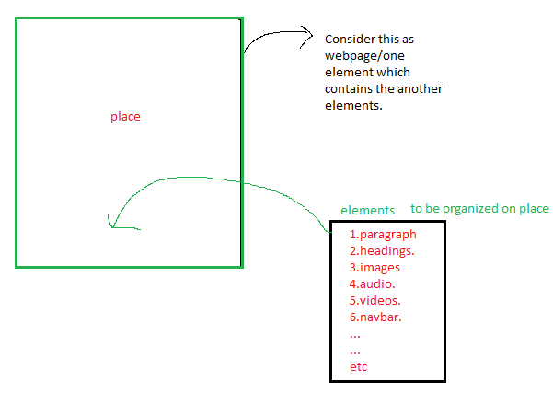s

Steps to implement webpage:

9.1. create lay out for entire webpage.

9.2. create lay out for elements on webpage. If element contains another elements.